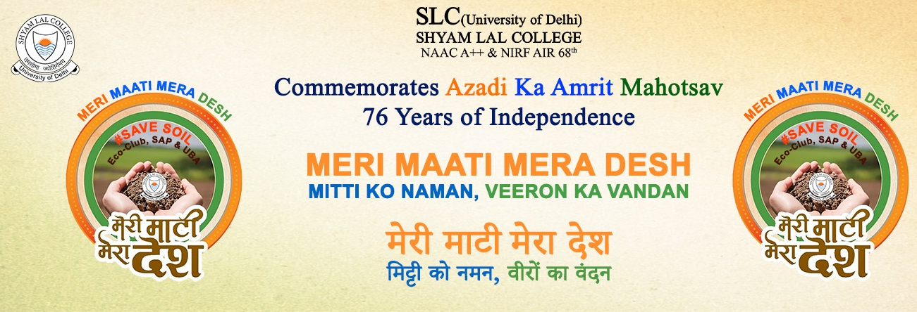
ECO-CLUB & UBA
Organised
"Exploring Alternative Energy: An Exhibition on Waste Utilization"

The Eco-Club & UBA of Shyam Lal College organized an exhibition in commemoration of Independence Day (15th Aug, 23), centred around the theme of "Renewable Energy." The event featured a variety of handmade models showcasing different renewable energy sources, including solar energy, windmills, the conversion of mechanical energy into electrical energy, Rain water harvesting system and more.
Our volunteer’s presentation included functional models that demonstrated the practical application of these renewable energy sources. These models aimed to educate and inspire audiences about the potential of sustainable energy solutions. In addition to the renewable energy models, our students showcased an array of sustainable handmade items such as small pots crafted from husk and coco peat, along with creatively designed items such as pen stands and decorations made from repurposed ice cream sticks. These items underscored the importance of upcycling and the creative utilization of materials that might otherwise go to waste.
The exhibition was presented to esteemed guests, including teachers, faculty members, and the college principal. Their presence and attention added a sense of significance to our efforts in promoting renewable energy and sustainability. Eco-Club & UBA of Shyam Lal College, are committed to continuing our efforts in raising awareness and promoting environmentally conscious practices within our college community and beyond.
